# Module 6 Activity 1: Advanced Middleware and Routing in Express.js

# Brandon Trinkle

# IFT 458: Middleware Programming

# Professor Dinesh Sthapit

# March 29, 2025

**Module 6 Activity 2: Advanced Middleware and Routing in Express.js**

*Screenshot 1: Of app.js showing the implementation of dynamic routes.*

*Screenshot 2: Of the middleware code for request validation in app.js.*

*Screenshot 3: Showing a route in app.js with a complex middleware chain.*

*Screenshot 4: Of the error handling middleware in app.js.*

*Screenshot 5: Showcasing test cases and responses for different error types.*

* *Running host on server*

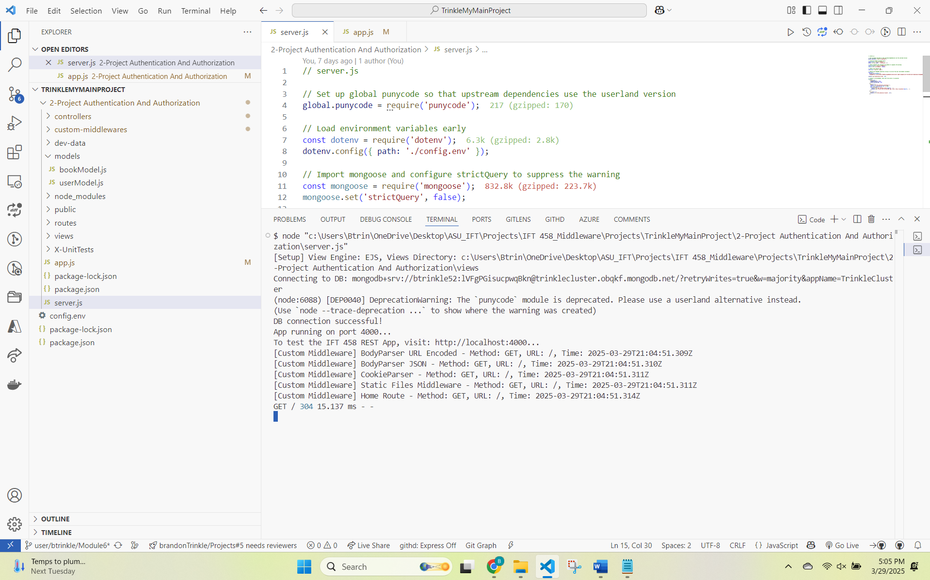

* *Logging in*